

Lin Chi-ling is 44 years old but still going strong. She was born in Taipei, a province of Taiwan on the 29th of November 1974. She is a model and actress. Lin Chi-Ling is the most popular Taiwanese model alive today. As an actress she is best known for her roles in Red *Cliff* (2008), *Beijing, New York* (2015) and *The Treasure Hunter*(2009).

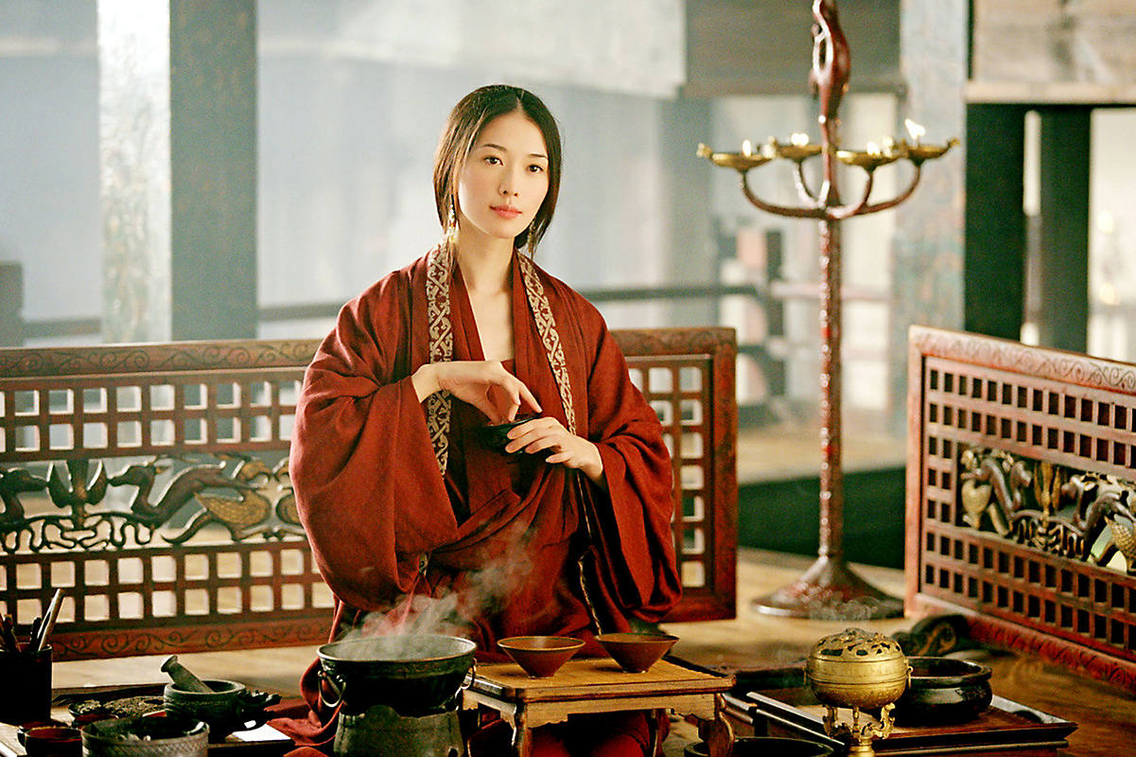

**In her first film, the Chinese epic Red Cliff, in 2008**

Lin’s parents are both from Tainan in Southern Taiwan but relocated to Taipei where their son Lin- Chi-hong and their daughter Lin Chi-ling were born. Lin early school days were spent at Taipei Municipal Zhongzheng Junior High School where she displayed talents in modelling. Her talents at school attracted the attention of a talent scout Lin Chien-huan.

However, her parents insisted she completed her education before embarking on a modeling career. They sent her to a private girls’ boarding school in Toronto, Canada known as Bishop Strachan School. On completion of her high school diploma she proceeded to University of Toronto where she studied Economics and Western Art History.



She graduated from University of Toronto in 1997 before returned to her home state Taipei where she had hoped to pursue a career in fine art. Alas, that was not to be. She needed a post-graduate degree to secure a job in a highly competitive fine art industry.

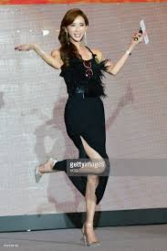

Lin had to make do with part-time modeling jobs for a while before getting a job as an administrative assistant in Fubon Cultural and Educational Foundation. She resigned from the job in 2000 and proceeded to Japan for a short three-month course in modeling. She was signed on by Catwalk Production House on her return from Japan.

This opened up many doors for her in the modelling world. In 2002 she got her first chance to model abroad in Hong Kong in a television advertisement that attracted a lot of attention from the Asian modeling community. As a result, her popularity soared and modeling organisers’ and producers’ interests began to grow.



Almost immediately she became a celebrity model. She was picked by Ge Hongfu, a popular television producer for the role of hostess of a fashion program on Shanghai Oriental Television in 2003. The following year, she starred in several advertisements on television, billboards and giant posters in Taiwan.

Her phenomenal success in modeling triggered what was to be known as ‘The Lin Chi-ling Phenomenon’, referring to the unprecedented recognition and demand for supermodels in Taiwan. Her fame soon spread to Hong Kong, Japan and mainland China.



She was particularly very successful in 2005 in Japan with a diverse set of clients marketing several top products. The government of Taiwan recognised the value of her image and appointed her as Taiwan's goodwill ambassador to the Japan Tourism Association. She served between 2004 and 2006.

Unfortunately disaster struck on 8 August 2005 in Dalian, China as she was shooting an advertisement for Procter & Gamble. She had an accident involving herself and the horse she was riding resulting in her sustaining serious injuries that included a punctured lung and six broken ribs. She was hospitalized for four months but returned to work in November 2005.



**Lin Chi-ling with Jay Chou in The Treasure Hunter**

With such a glorious career in modelling one wonders why she would venture into acting.

The answer, according to Lin Chi-ling herself is that, “It was as if I was being pulled into the entertainment industry. Aged 24, I knew I couldn’t count on a long modelling career, so I needed to have another avenue of work. I started hosting a TV fashion programme in Taiwan, and suddenly I was jetting off to fashion weeks around the world, interviewing Karl Lagerfeld. I couldn’t believe it!”